Devin Hardy

00076619

CS423

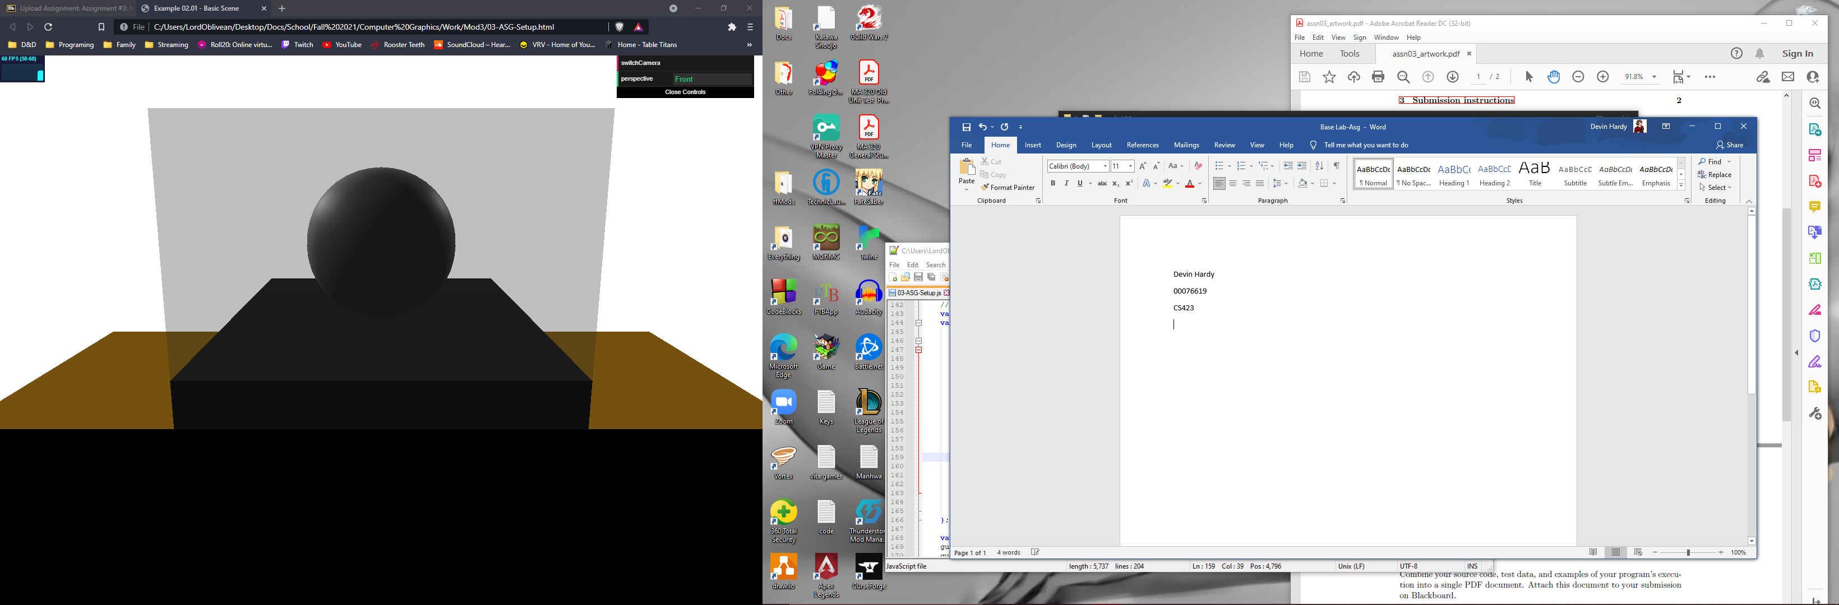

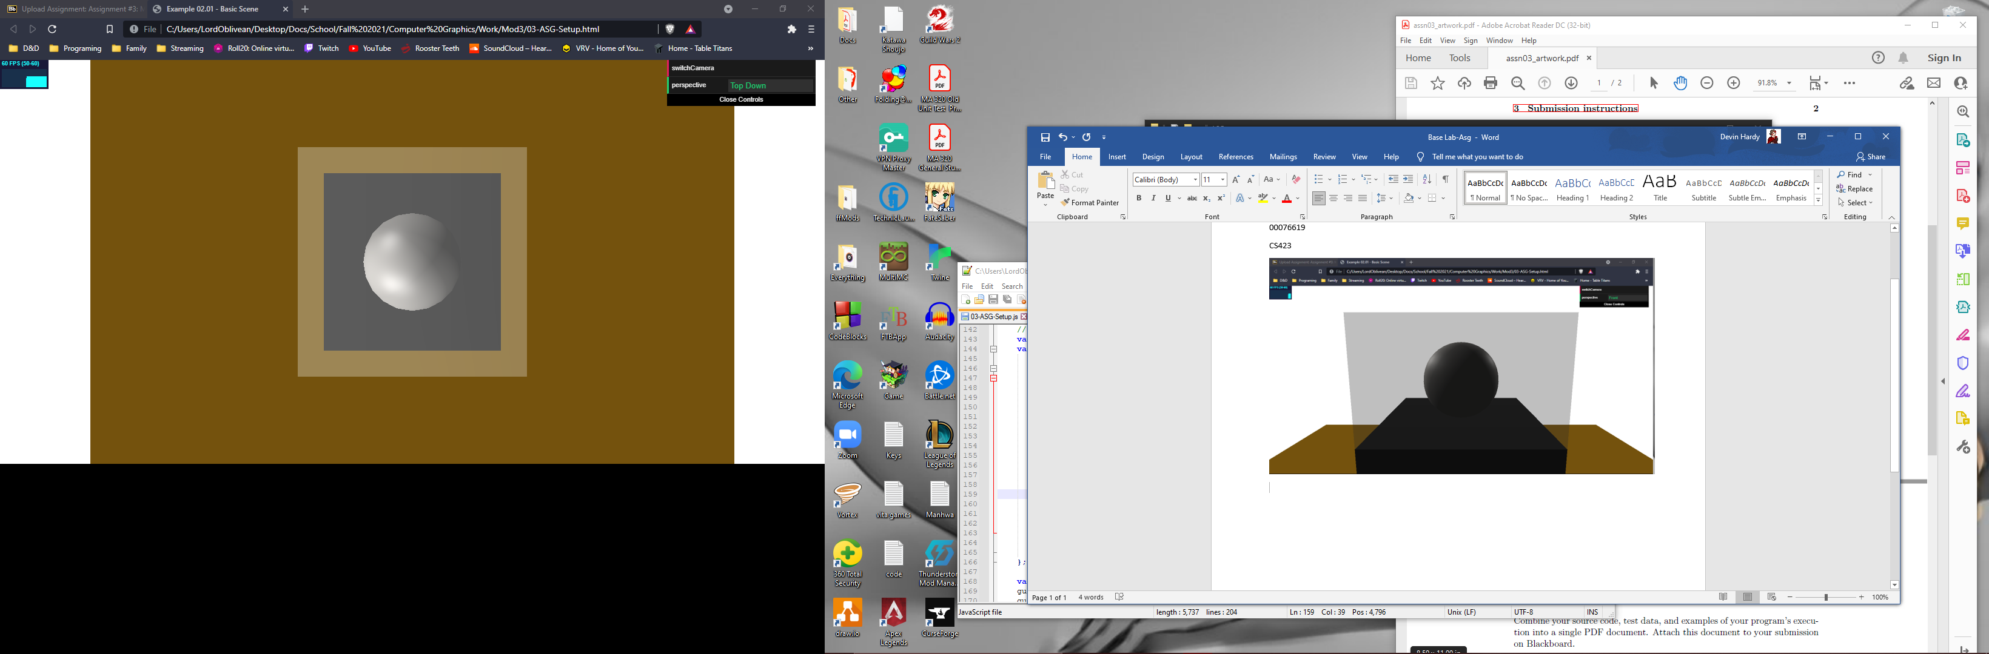

<!DOCYTPE html>

<HTML>

<HEAD>

<TITLE>Example 02.01 - Basic Scene</TITLE>

<SCRIPT TYPE="text/javascript" SRC="../libs/three.js"></SCRIPT>

<SCRIPT TYPE="text/javascript" SRC="../libs/stats.min.js"></SCRIPT>

<SCRIPT TYPE="text/javascript" SRC="../libs/dat.gui.min.js"></SCRIPT>

<STYLE>

body {

/\* set margin to 0 and overflow to hidden, to go fullscreen \*/

margin: 0;

overflow: hidden;

}

</STYLE>

</HEAD>

<BODY>

<DIV id="Stats-output">

</DIV>

<!-- DIV which will hold the Output -->

<DIV id="WebGL-output">

</DIV>

<!-- Javascript code that runs our Three.js examples -->

<SCRIPT TYPE="text/javascript" SRC="03-ASG-Setup.js">

</SCRIPT>

</BODY>

</HTML>

//

// File:

// Author:

// Purpose:

//

function init() {

var stats = initStats();

// create a scene, that will hold all our elements such as objects, cameras and lights.

var scene = new THREE.Scene();

// create a camera, which defines where we're looking at.

var camera = new THREE.PerspectiveCamera(45, window.innerWidth / window.innerHeight, 0.1, 1000);

camera.position.x = 30;

camera.position.y = 30;

camera.position.z = 0;

// create a render and set the size

var renderer = new THREE.WebGLRenderer();

renderer.setClearColor(new THREE.Color(0xEEEEEE, 1.0));

renderer.setSize(window.innerWidth, window.innerHeight);

// create the ground plane

var planeGeometry = new THREE.PlaneGeometry(180, 180);

var planeMaterial = new THREE.MeshBasicMaterial({color: 0x74520D});

var plane = new THREE.Mesh(planeGeometry, planeMaterial);

// rotate and position the plane

plane.rotation.x = -0.5 \* Math.PI;

plane.position.x = 0;

plane.position.y = 0;

plane.position.z = 0;

// add the plane to the scene

scene.add(plane);

// Room

var cubeGeometry = new THREE.BoxGeometry(1,100,100);

var cubeMaterial = new THREE.MeshBasicMaterial({color: 0xFFFFFF});

var cube = new THREE.Mesh(cubeGeometry, cubeMaterial);

cube.position.x = 50;

cube.position.y = 25;

cube.position.z = 0;

scene.add(cube);

var cubeGeometry = new THREE.BoxGeometry(100,100,1);

var cubeMaterial = new THREE.MeshBasicMaterial({color: 0xFFFFFF});

var cube = new THREE.Mesh(cubeGeometry, cubeMaterial);

cube.position.x = 0;

cube.position.y = 25;

cube.position.z = 50;

scene.add(cube);

var cubeGeometry = new THREE.BoxGeometry(1,100,100);

var cubeMaterial = new THREE.MeshBasicMaterial({color: 0xFFFFFF});

var cube = new THREE.Mesh(cubeGeometry, cubeMaterial);

cube.position.x = -50;

cube.position.y = 25;

cube.position.z = 0;

scene.add(cube);

var cubeGeometry = new THREE.BoxGeometry(100,100,1);

var cubeMaterial = new THREE.MeshBasicMaterial({color: 0xFFFFFF});

var cube = new THREE.Mesh(cubeGeometry, cubeMaterial);

cube.position.x = 0;

cube.position.y = 25;

cube.position.z = -50;

scene.add(cube);

// Pedestal cube

var cubeGeometry = new THREE.BoxGeometry(20,20,20);

var cubeMaterial = new THREE.MeshLambertMaterial({color: 0x0F0F0F});

var cube = new THREE.Mesh(cubeGeometry, cubeMaterial);

cube.position.x = 0;

cube.position.y = 10;

cube.position.z = 0;

scene.add(cube);

// Item Sphere

var sphereGeometry = new THREE.SphereGeometry(5, 20, 20);

var sphereMaterial = new THREE.MeshPhongMaterial({color: 0x64625F});

var sphere = new THREE.Mesh(sphereGeometry, sphereMaterial);

sphere.position.x = 0;

sphere.position.y = 25;

sphere.position.z = 0;

scene.add(sphere);

var directionalLight = new THREE.DirectionalLight(0xffffff, 0.7);

directionalLight.position.set(-20, 40, 60);

scene.add(directionalLight);

// Attempt at glass box

var cubeGeometry = new THREE.BoxGeometry(20,15,20);

var cubeMaterial = new THREE.MeshPhongMaterial({color: 0xF7F7F7, opacity: 0.3, transparent: true});

var cube = new THREE.Mesh(cubeGeometry, cubeMaterial);

cube.position.x = 0;

cube.position.y = 25;

cube.position.z = 0;

scene.add(cube);

// SpotLights

var spotLight1 = new THREE.SpotLight(0xffffff);

spotLight1.position.set(-49, 50, -49);

spotLight1.castShadow = true;

scene.add(spotLight1);

spotLight1.target.position.set(0, 25, -1);

scene.add(spotLight1.target)

var spotLight2 = new THREE.SpotLight(0xffffff);

spotLight2.position.set(-49, 50, 49);

spotLight2.castShadow = true;

scene.add(spotLight2);

spotLight2.target.position.set(0, 25, 1);

scene.add(spotLight2.target)

// add subtle ambient lighting

var ambientLight = new THREE.AmbientLight(0x292929);

scene.add(ambientLight);

// add the output of the renderer to the html element

document.getElementById("WebGL-output").appendChild(renderer.domElement);

// call the render function

var step = 0;

// Insert Lab03 code here.

// New Controls

var camSpot = 1;

var controls = new function () {

this.perspective = "Front";

this.switchCamera = function () {

if (camSpot == 0) {

camSpot = 1;

camera = new THREE.PerspectiveCamera(45, window.innerWidth / window.innerHeight, 0.1, 1000);

camera.position.x = 30;

camera.position.y = 30;

camera.position.z = 0;

camera.lookAt(0, 25, 0);

this.perspective = "Front";

} else {

camSpot = 0;

camera = new THREE.PerspectiveCamera(45, window.innerWidth / window.innerHeight, 0.1, 1000);

camera.position.x = 0;

camera.position.y = 75;

camera.position.z = 0;

camera.lookAt(0, 25, 0);

this.perspective = "Top Down";

}

};

};

var gui = new dat.GUI();

gui.add(controls, 'switchCamera');

gui.add(controls, 'perspective').listen();

// make sure that for the first time, the

// camera is looking at the scene

camera.lookAt(0, 25, 0);

render();

function render() {

stats.update();

// render using requestAnimationFrame

requestAnimationFrame(render);

renderer.render(scene, camera);

}

function initStats() {

var stats = new Stats();

stats.setMode(0); // 0: fps, 1: ms

// Align top-left

stats.domElement.style.position = 'absolute';

stats.domElement.style.left = '0px';

stats.domElement.style.top = '0px';

document.getElementById("Stats-output").appendChild(stats.domElement);

return stats;

}

}

window.onload = init